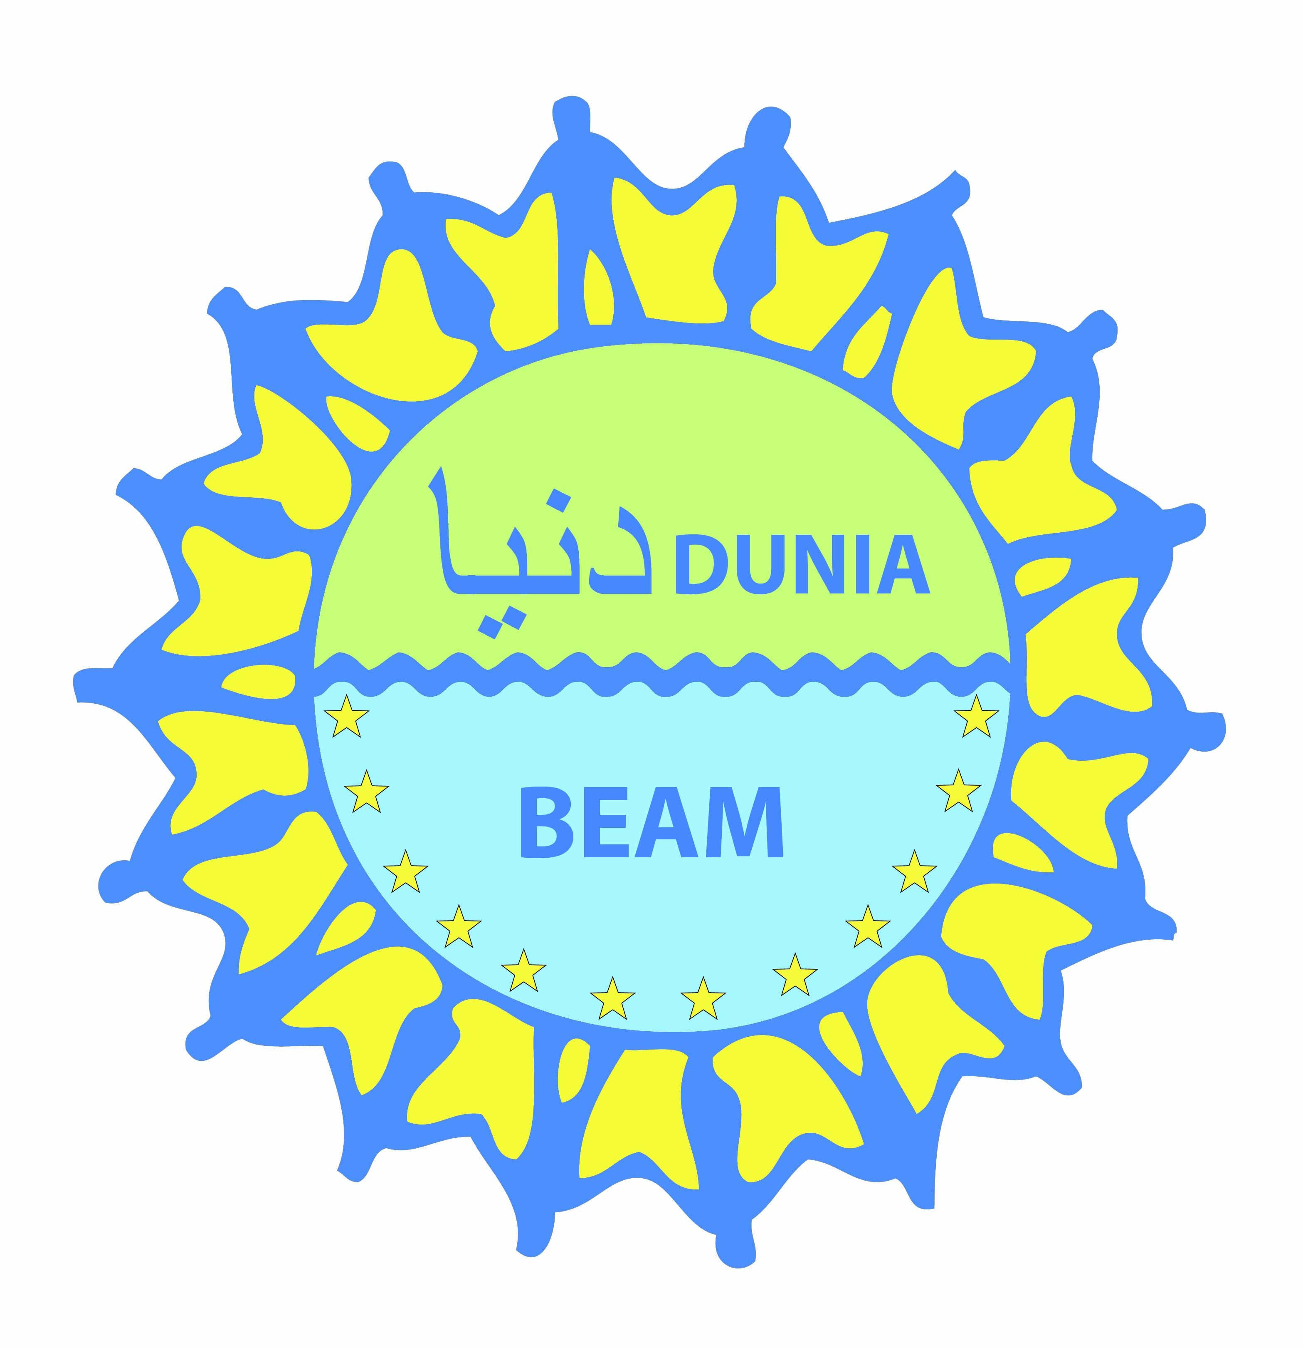

Erasmus Mundus – DUNIA BEAM
Develop a University Network for Improving
the move-Ability between Europe and
Middle-East
Erasmus Mundus Action 2 – Strand 1
Lot 2: Jordan, Lebanon, Occupied Palestinian territory, Syria
www.duniabeam.eu

University Information Sheet

UNIVERSITY OF PAVIA

Key Data on the Institution
Head of Institution | RECTOR, PROF. ANGIOLINO STELLA
Address | Corso Strada Nuova, 65 27100 Pavia, Italy
Erasmus Mundus Coordinator | Prof. Gianni Vaggi, Pro – Rector for International Relations
Websites | http://www.unipv.it, www.studiareapavia.it
General Website | http://www.unipv.it
Website with specific information for Erasmus Mundus applicants | Soon online
E-mail: | duniabeam@unipv.it

Academic calendar (lecture periods)
- Link to academic calendar | http://www.unipv.eu/site/en/home/international-relations/erasmus/incoming-students/before-the-arrival/articolo1336.html
- Lecture periods
first term 2013/2014 (winter term) | start date: 15/09/2013 | end date: 28/02/2014
 | registration session / periods: 15/09/2013
 | examination period(s): January – February 2014
second term 2013/2014 (summer term) | start date: 28/02/2014 | end date: 30/06/2014
 | registration session / periods February 2014
 | examination period(s): June – July 2014

Admission and registration

THOSE INFORMATION DEPENDS ON EACH COMPONENT OF THE UNIVERSITY/ SPECIALITY/ WHEN THE STUDENT IS SELECTED THE ERASMUS MUNDUS TEAM CONTACT DIRECTLY THE PERSON IN CHARGE TO PROCEED TO THE ADMINISTRATIVE ASPECT OF THE MOBILITY)

Exchange students (credit transfer, non degree seeking)
undergraduate | Admission deadline  May 2013
undergraduate | Registration deadline  June 2013
undergraduate | contact information |  | duniabeam@unipv.it
 | Application Form Website |  | Soon available
master | Admission deadline  May 2013 |  | Admission deadline  May 2013
master | Registration deadline  June 2013 |  | Registration deadline  June 2013
master | contact information |  | contact information
 | Application Form Website |  | Application Form Website
PhD – Doctorate | admission requirements |  | http://www.unipv.eu/site/en/home/research/research-doctorates-ph.d.html
PhD – Doctorate | admission deadline |  | May 2013
PhD – Doctorate | registration deadline |  | November 2013
PhD – Doctorate | contact information |  | duniabeam@unipv.it
 | Application Form Website |  | Soon available
Degree seeking students (full programmes)
undergraduate | admission requirements |  | Please see:  http://www.unipv.eu/site/en/home/academics/faculties.html
undergraduate | Admission deadline |  | June 2013
undergraduate | Registration deadline |  | September 2013
undergraduate | contact information |  | duniabeam@unipv.it
Master | admission requirements |  | http://www.unipv.eu/site/en/home/academics/faculties/degrees-in-english.html
Master | Admission deadline |  | June 2013
Master | Registration deadline |  | September 2013
Master | contact information |  | duniabeam@unipv.it
Phd - Doctorates | admission requirements |  | http://www.unipv.eu/site/en/home/research/research-doctorates-ph.d.html
Phd - Doctorates | Admission deadline |  | July 2013
Phd - Doctorates | Registration deadline |  | November 2013
Phd - Doctorates | contact information |  | duniabeam@unipv.it
Course information websites
Undergraduate studies |  | http://www.unipv.eu/site/en/home/academics/faculties.html
Master programmes |  | http://www.unipv.eu/site/en/home/academics/faculties/degrees-in-english.html
Doctorate programmes |  | http://www.unipv.eu/site/en/home/research/research-doctorates-ph.d.html

Language requirements
Language of instruction A: | language | English
 | required level | At least B2
 | accepted certificate(s) | No special certificates
Language of instruction B: | language | Italian
 | required level | At least B2
 | accepted certificate(s) | No special certificates

Student and welcome services
Link to student guide | Soon available
Estimated living expenses | Depending on the housing, between 600 and 800.7
Housing | housing assistance  (yes/no/type) | University residence, or private rooms/flats depending on the preference of the scholar
 | link to housing  information | http://www.centroassistenzastudenti.it/erasmus.html
 | Website  Deadline  Contact | duniabeam@unipv.it
Facilities for students with special needs | Home automation rooms in University Residences for handicapped people  Special department in charge of helping handicapped people: http://saisd.unipv.it/
Welcome event / orientation week | Welcome event for Erasmus Mundus students  Visits of Pavia City as well as other European cities
- Language course(s) | Before the study periods | September (1 semester)  February (2 semester)
 | During the study periods | October – January  February – June  http://cla.unipv.it/?page_id=171

International Office / Student Service Center / Visitor Service
Mailing address | International Relations Office  University of Pavia  Corso Strada Nuova 65, 27100 Pavia, Italy
Phone | +39 0382 98 6938
Website/email | http://www.unipv.eu/site/en/home/international-relations.html
Contact persons
Students | incoming | duniabeam@unipv.it
Students | outgoing | duniabeam@unipv.it
Phd/Doctorate | incoming | duniabeam@unipv.it
Phd/Doctorate | outgoing | duniabeam@unipv.it
Post-doc/Staff | incoming | duniabeam@unipv.it
Post-doc/Staff | outgoing | duniabeam@unipv.it

